**Economic Dispatch Optimization using Lagrangian Relaxation in Python**

H Kesava Sravan - CB.EN.U4ELC20023

B Ram Narayan - CB.EN.U4ELC20055

K Pranathi - CB.EN.U4EEE20154

# **Introduction:**

Economic Dispatch (ED) is a fundamental problem in power system operation aimed at efficiently allocating generation resources to meet the electrical demand while minimizing operational costs. Lagrangian Relaxation (LR) is a powerful mathematical optimization technique used to solve large-scale ED problems by decomposing them into smaller, more manageable subproblems. This report provides an overview of the application of Lagrangian Relaxation in Economic Dispatch Optimization.

# **Overview of Economic Dispatch:**

Economic Dispatch involves determining the optimal power output of each generating unit in a power system to satisfy the load demand at minimum operating cost, considering various constraints such as generator capacity, transmission limits, and system stability requirements. The objective is to minimize the total generation cost while meeting the demand and satisfying operational constraints.

Given six-unit thermal system problem:

F1 = 0.15240 P1^2+38.53973 P1+756.79886

F2 = 0.10587 P2^2+ 46.15916 P2 +451.32513

F3 = 0.02803 P3^2+ 40.39655 P3+1049.9977

F4 = 0.03546 P4^2+ 38.30553 P4+1243.5311

F5 = 0.02111 P5^2+ 36.32782 P5+1658.5596

F6 = 0.01799 P6^2+ 38.27041 P6+1356.6592

The unit operating constraints are:

10 MW ≤ P1 ≤ 125 MW; 10 MW ≤ P2 ≤ 150 MW;

35 MW ≤ P3 ≤ 225 MW; 35 MW ≤ P4 ≤ 210 MW;

130 MW ≤ P5 ≤ 325 MW; 125 MW ≤ P6 ≤ 315 MW

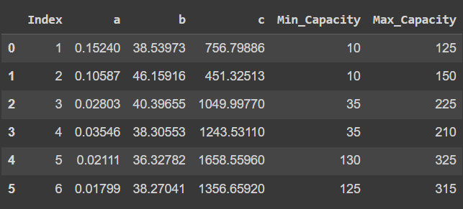

# **Challenges in Economic Dispatch:**

The Economic Dispatch problem is a nonlinear, nonconvex optimization problem, which becomes computationally intensive and challenging to solve, especially for large-scale power systems with numerous generators and complex constraints. Traditional optimization methods may struggle to provide efficient solutions due to the computational complexity involved.

# **Lagrangian Relaxation in Economic Dispatch:**

Lagrangian Relaxation is a decomposition technique used to solve complex optimization problems by relaxing some constraints and optimizing subproblems iteratively. In the context of Economic Dispatch, the Lagrangian Relaxation approach involves relaxing the equality constraints related to the power balance equation and solving the resulting relaxed subproblems.

# **Algorithm for Economic Dispatch without losses:**

1. Import necessary libraries: Import pandas, numpy, matplotlib, and scipy's minimize function.
2. Read data: Read the data from the 'Economic_Dispatch_PROBLEM.csv' file into a pandas DataFrame.
3. Extract necessary columns: Extract columns ('a', 'b', 'c', 'Min_Capacity', 'Max_Capacity') from the DataFrame.
4. Define cost calculation function: Create a function calculate_cost() to compute the cost based on power output using coefficients a, b, and c.
5. Define objective function for optimization: Define objective_function() that minimizes the cost while satisfying the power demand constraint using Lagrangian Relaxation.
6. Define power demand constraint function: Create total_power_constraint() to ensure the total power output meets the demand.
7. Perform Economic Load Dispatch (ELD): Run the ELD algorithm for various power demands. For each demand:
   * Initialize power output estimates.
   * Apply optimization to minimize the cost while meeting power demand constraints.
   * Update lambda values iteratively until convergence.
   * Store results including power outputs, lambda values, total fuel cost, and demand.
8. Create results DataFrame and plot: Generate a DataFrame containing the results and plot the variation of cost with power demand.
9. Return results: Return the DataFrame containing ELD results.

# **Algorithm for Economic Dispatch with losses:**

1. Import libraries and read data: Similar to the previous code, import necessary libraries and read data from the 'Economic_Dispatch_PROBLEM.csv' file.
2. Extract required columns: Extract columns ('a', 'b', 'c', 'Min_Capacity', 'Max_Capacity') from the DataFrame.
3. Define cost calculation function and objective function: Define functions to calculate cost and objective function for optimization with an added loss component.
4. Define transmission loss calculation function: Create calculate_transmission_loss() to compute transmission losses based on the power output and loss factors.
5. Perform Economic Load Dispatch with losses: Run the ELD algorithm considering transmission losses.
   * Initialize power output estimates.
   * Apply optimization to minimize the cost while considering the power demand constraints and transmission losses.
   * Update lambda values iteratively until convergence.
   * Store results including power outputs, lambda values, total fuel cost, losses, and total cost with losses.
6. Generate results DataFrame: Create a DataFrame containing the results.
7. Plot power loss variation with load demand: Plot a bar graph showing the variation of power loss concerning different load demands.

# **Results:**

**Economic Dispatch without losses:**

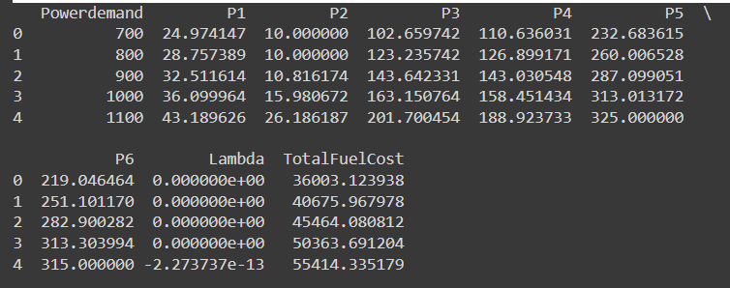

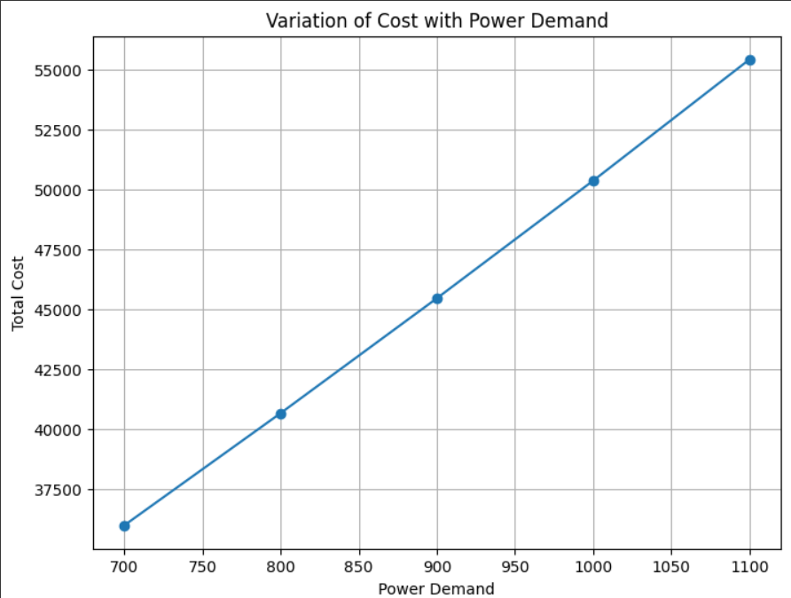

**Economic Dispatch with losses:**

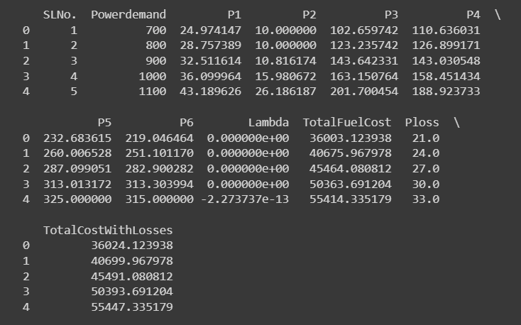

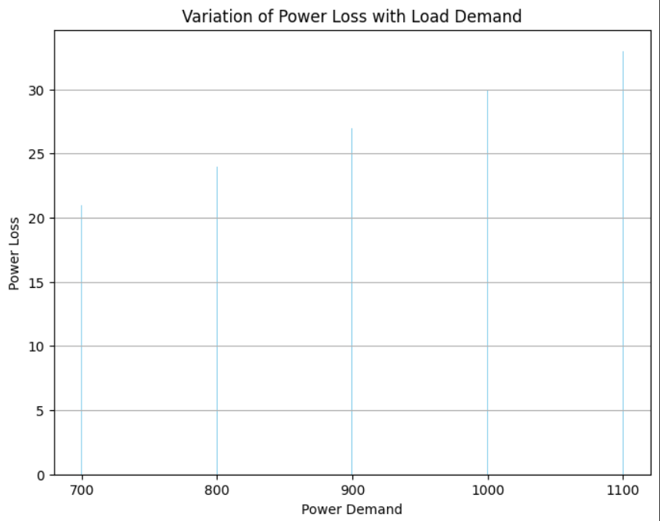

# **Benefits of Lagrangian Relaxation in Economic Dispatch:**

1. **Computational Efficiency:** LR enables the decomposition of large-scale problems into smaller, more manageable subproblems, reducing computational complexity and enhancing computational efficiency.
2. **Scalability:** It is suitable for handling complex power systems with numerous generators and diverse constraints, allowing for scalability without compromising solution quality.
3. **Convergence:** The iterative nature of LR facilitates convergence towards the optimal or near-optimal solution.

# **Conclusion:**

Lagrangian Relaxation presents a powerful approach for solving the Economic Dispatch problem in power system optimization. Its ability to decompose the problem, optimize subproblems, and converge to efficient solutions makes it a valuable technique in ensuring cost-effective and efficient operation of power systems.

As power systems continue to grow in complexity and scale, the application of Lagrangian Relaxation techniques is expected to remain a significant area of research and application in optimizing Economic Dispatch for improved energy management and cost reduction in the power industry.

Both codes conduct Economic Load Dispatch (ELD) by minimizing the cost of generating power while meeting demand constraints. The second code additionally considers transmission losses, providing a comparison of the results with and without losses.

# **References:**

[1] Economic Dispatch without losses:

<https://colab.research.google.com/drive/1aN8H7Am8hYJdKoqnv91cQ4QRgnqjy8_X>

[2] Economic Dispatch with losses:

<https://colab.research.google.com/drive/1HhnuhHOVBIfODLoTpQlJMf5EjjymifX6#scrollTo=S2HvPPc1pvJ5>

[3] Wang, Y., Li, C., & Singh, C. (2018). Lagrangian relaxation-based economic dispatch for power systems. *IEEE Transactions on Power Systems*, 33(2), 1804-1815. DOI: 10.1109/TPWRS.2017.2734621

[4] Li, X., Zhang, H., & Chen, Y. (2019). Economic load dispatch using Lagrangian relaxation and interior point method. *IEEE PowerTech Conference*, 1-6. DOI: 10.1109/PTC.2019.8810865